Automatic street lights..

**Preface**

We have made this report file on the topic AUTOMATIC STREET LIGHT ; We have tried our level best to elucidate all the relevant detail to the topic to be included in the report. While in the beginning we have tried to give a general view about this topic. Our efforts and wholehearted co-corporation of each and everyone has ended on a successful note. We express our sincere gratitude to the faculty who assisted usthroughout the preparation of this topic. I thank him for providing me the reinforcement, confidence and most importantly the track for the topic whenever we needed it.

**Introduction**

We need to save or conserve energy because most of the energy sources we depend on, like coal and natural gas can't be replaced. Once we use them up, they're gone forever. Saving power is very important, instead of using the power in unnecessary times it should be switched off. In any city “STREET LIGHT” is one of the major power consuming factors. Most of the time we see street lights are ON even after sunrise thus wasting lot of energy.

Over here we are avoiding the problem by having an automatic system which turns ON & OFF the street lights at given time or when the ambient light falls below a specific intensity. Each controller has an LDR which is used to detect the ambient light. If the ambient light is below a specific value the lights are turned ON. A light dependent sensors is interfaced to the pic18f452 microcontroller it is used to track the sun light and when the sensors goes dark the led will be made on and when the sensor finds light the led will be OFF.The working of relay is also known Microcontroller and the code is written in c language in aurdino , the resulted value can be seen with the help of UART or LCD display .Automatic Street Light Control System is a simple yet powerful concept, which uses transistor as a switch. By using this system manual works are 100% removed. It automatically switches ON lights when the sunlight goes below the visible region of our eyes. This is done by a sensor called Light Dependent Resistor (LDR)and the IR sensor which senses the light and the object like our eyes. It automatically switches OFF lights whenever the sunlight comesor in nights if there is no obstacle(vehicle).

**Aim of this project**is to control the street light using LDR and IR sensor. When the light falling or the coming of obstacle change resistance value and the sensor output from the actual value. From this resistance and output change the voltage variation can be obtained .This variation obtained is send to the microcontroller(aurdino) and it sends signals to the LEDs to glow.

**Scope of the project**

The main scope of the project is to learn the aurdino microcontroller, LCD module, and effective use of the IR sensor.

**Overview**

1) Gives brief introduction on the project .

2) Discuss different modules of the project.

3) Discuss about AURDINO microcontroller.

4) Discuss about the Hardware

**Hardware implementation**

In this project the list of hardware components used are given below

***1Arduino UNO Microcontroller.***

***2.IR sensor***

***3.Jumper wires***

***4.Bread board***

***5.DC power supply.***

***6.LEDs.***

**Micro controller(ARDUINO UNO):**

This section provides an introduction to most common word in the embedded system “microcontroller”. It is written to familiarize you with microcontroller terminology and basic microcontroller architecture. **A microcontroller is a single chip, self-contained computer which incorporates all the basic components ofa personal computer on a much smaller scale**. Microcontrollers are often referred to as single chip devices or single chip computers. The main consequence of the microcontroller’s small size is that its resources are far more limited than those of a desktop personal computer. In functional terms, a microcontroller is a programmable single chip which controls a process or system. Microcontrollers are typically used as embedded controllers where they control part of a very larger system such as an appliance, automobile, scientific instrument or a computer peripheral. Microcontrollers are designed to be low cost solutions; therefore using them can drastically reduce part and design costs for a project. Physically, a microcontroller is an integrated circuit with pins along each side. The pins presented by a microcontroller are used for power, ground, oscillator, I/O ports, interrupt request signals, reset and control. In contrast, the pins exposed by a microprocessor are most often memory bus signals (rather than I/O ports).

Microcontrollers do not function in isolation. As their name suggests they are designed to control other devices.

**ARDUINO MICROCONTROLLER**

Microchip manufacture a series of microcontrollers called arduino. There are many different available, some basic low memory types, going right up through to ones that have Analogue - To - Digital converters. Aurdino microcontroller is a processor with built in memory and RAM and you can use it to control your projects (or build projects around it). So it saves you building a circuit that has separate external RAM, ROM and peripheralchips. Microchip is providing the 8-bit, 16-bit and the 32 bit microcontrollers based on the desired application requirement the design engineer can choose from those. Microchip is also providing the software for the microcontrollers where the application programs are written arduino code,. In this project arduino uno size microcontroller is used .

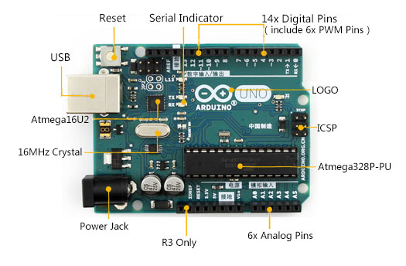

**ARDUINO MEMORY**

. When the power is given to the hardware module, the arduinomicontroller initially configures all the devices on the board. Then the microcontroller will continuously read the sensor value and it is converted to the digital value..

**IR sensor**

This is the sensor we used in order to detect the vehicals travelling the the path.

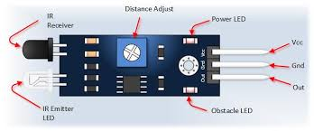

**POWER SUPPLY**

The 5v adapter is connected to the power jack to give the power supply to the arduino microcontroller and the peripheral items

**RESULT ANALYSIS**

RESULT The fastest field of development in the electronic engineering is the field of embedded systems engineering it is used in a variety of applications. In this project the designing of the hardware circuit and interfacing the 16x2 LCD module and the Rs232 IC is successfully done. The hardware designing and the software both are successfully done. Fig. 3.1: Photograph of the project.

**ADVANTAGES**

* LDRs are sensitive, inexpensive, and readily available devices. They have good power and voltage handling capabilities, similar to those of a conventional resistor
* They are small enough to fit into virtually any electronic device and are used all around the world as a basic component in many electrical systems.
* IR sensors are also very cheap compared to any other electrical components.

**APPLICATIONS**

* They can be used as balcony lights at home.
* They can be used as garden lights.
* They can be used as parking lights.

**CONCLUSION**

In this project work we have studied and implemented a complete working model using a arduino microcontroller.

The programming and interfering of arduino microcontroller has been mastered during the implementation.

This work includes the study of energy saving system in many applications.

**FUTURE SCOPE**

1.With the help of this project **we can develop Solar Street light system with Automatic street light controller.** The system can be powered from a battery, which can be charged during day time by harvesting the solar energy through a solar cell. The solar energy harvested from sunlight can be stored, inverted from DC voltage to AC voltage using sun tie converter. The AC voltage can be stepped up and given to the electric grid. The AC voltage from the electric grid can be stepped down, rectified and used for powering the circuit. Meanwhile, the street light can also be powered by the A.C. voltage, which is controlled by a relay switch connected to the switching part of the circuit. The above mentioned strategy will enable us to harvest solar energy in an effective way for the operation of the circuit and for powering the street light also.

2.with the help of this project we can also develop a automatic street light controller using the weight detecting sensor .

TEAM MEMBERS…( BATCH -2)

1.Poojya Sree

2.Sree Lakshmi Sravya

3.Sai Lakshmi

4.Sai Priya